Crossword puzzle
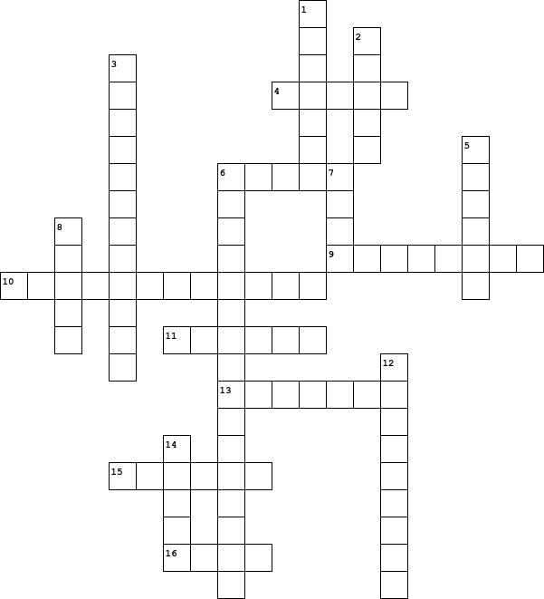

  Across
  4. | to look hard at something or someone for a long time
  6. | someone who works in an office, writing letters
  9. | a coin in old British money
  10. | December 24th, a day before Christmas
  11. | nonsense, silly ideas; dishonest or untrue words
  13. | A mean old man
  15. | Scrooge's long-dead partner
  16. | very small
  Down
  1. | someone who owns a business with another person
  2. | happy, cheerful
  3. | a thing shaped like a tall hat, which you put on a candle to stop it from burning
  5. | the ghost of a dead body
  6. | His torch gives every dinner a special taste
  7. | to touch someone lovingly, with your lips
  8. | a special song that people sing at Christmas
  12. | very pleased and happy
  14. | A thin white cover of ice on the ground in the very cold weather

